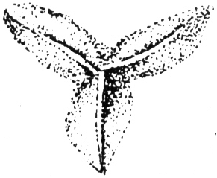
Biopharm Leeches
Bryngelen Manor
2 Bryngwili Road
Hendy, Carms
SA4 0XT

Tel : (01792) 885595

FAX : (01792) 882440
sales@biopharm-leeches.com
www.biopharm-leeches.com
Suppliers of Leeches since 1812

DISCLAIMER
THIS FORM IS FOR UK & EU CUSTOMERS ONLY

I (PRINT NAME) ____________________________________ hereby confirm that I have been advised of the risks involved with leech therapy – namely the presence of the gut bacterium known as Aeromonas hydrophila within all medicinal leeches. Further information can be found on the Biopharm Leeches website at:

http://www.biopharm-leeches.com/contraindications.html

I confirm that the leeches are solely for personal use and that I am not using any blood thinning medication and/or do not suffer from any blood disorders, immunodeficiency disorders or Diabetes.

I understand that Biopharm strongly recommends before using any leeches that I discuss their use with a medically trained professional. I accept full liability for the treatment and will not hold Biopharm or its employees accountable for any complications that may result from the application of the leeches.

Signed: _________________________________________ Date: _______________
(MUST be Hand-Signed)

Email address: ________________________________________

Contact number: ________________________________________

Postal Address: ________________________________________
________________________________________
________________________________________
________________________________________

Please return all completed forms to:

Email: uksales@biopharm-leeches.com

Photo message: 07971470446

Post: Biopharm Leeches, 2 Bryngwili Road, Hendy, Carmarthenshire, SA4 0XT

